|  |
| --- |
|  |
| 新概念 3 册 |
| Lesson47 Too high a price? |

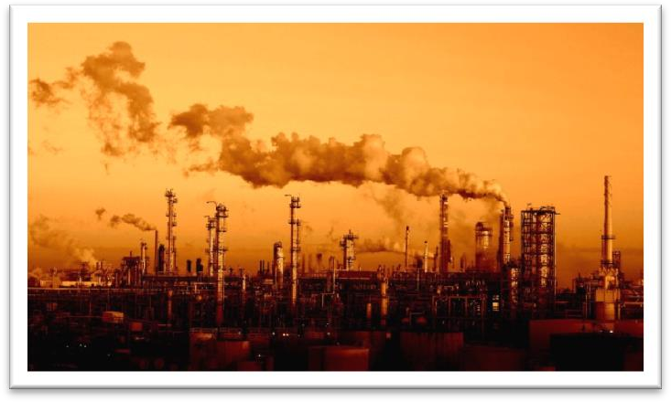

Book

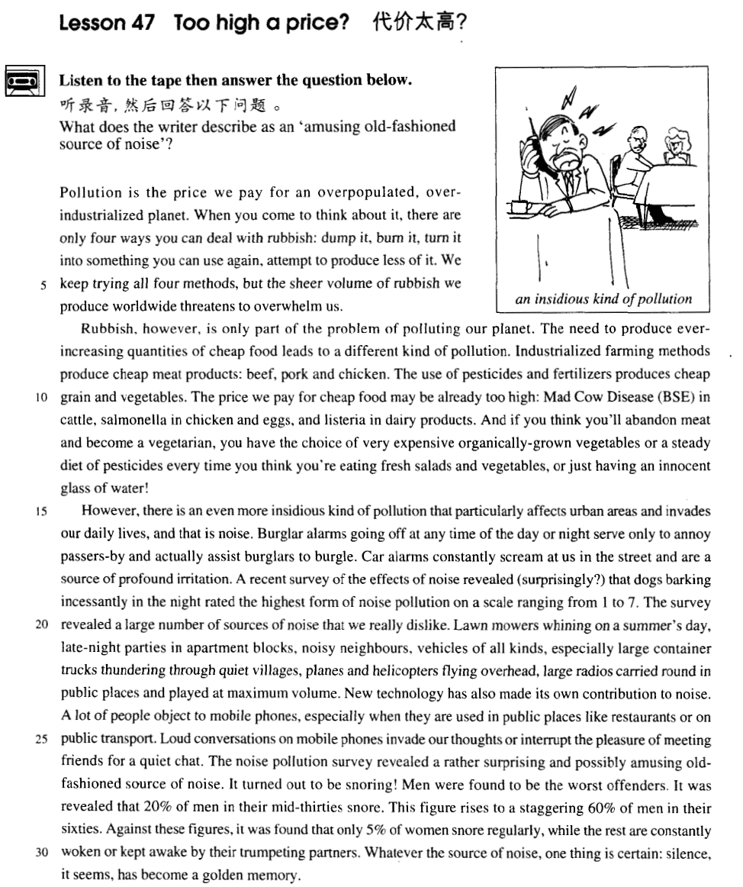

课文

Pollution is the price we pay for an overpopulated, overindustrialized planet.

污染就是我们为这个人口过密，过度工业化的星球所付出的代价。

When you come to think about it, there are only four ways you can deal with rubbish: dump it, burn it, turn it into something you can use again, attempt to produce less of it.

当我们开始考虑垃圾问题时，我们只有4种对付垃圾的方法：倾倒、焚烧、把垃圾变成再生材料或试图少产生一些垃圾。

We keep trying all four methods, but sheer volume of rubbish we produce worldwide threatens to overwhelm us.

我们一直在试这4种方式，但是，我们在世界范围内仅产生的垃圾的量就有把我们覆盖的危险。

Rubbish, however, is only part of the problem of polluting our planet.

然而，垃圾只是我们这个星球的污染问题的一个方面。

The need to produce ever-increasing quantities of cheap food leads to a different kind of pollution.

日益增长的对廉价食物的需求导致了另一种形式的污染。

Industriallized farming methods produce cheap meat products: beef, pork and chicken.

工业化的农作方式生产出廉价的肉类制品--牛肉、猪肉和鸡肉。

The use of pesticides and fertilizers produces cheap grain and vegetables.

使用杀虫剂和化肥生产出廉价的谷物和蔬菜。

The price we pay for cheap food may be already too high: Mad Cow Disease (BSE) in cattle, salmonella in chicken and eggs, and listeria in dairy products.

为了廉价食物我们付出代价已经太高了：牛肉中的疯牛病，鸡肉和鸡蛋中的沙门氏菌，奶制品中的利斯特杆菌。

And if you think you'll abandon meat and become a vegetarian, you have the choice of very expensive organically-grown vegetables or a steady diet of pesticides every time you think you're eating fresh salads and vegetables, or just having an innocent glass of water!

如果你想放弃肉类而变成一位素食者，那么你可以两者择一：或是选用价格昂贵、有机培植的蔬菜，或是当你认为在享用新鲜色拉和新鲜蔬菜或饮用一杯无害的水的时候，实际上每次都不断吃进杀虫剂。

However, there is an even more insidious kind of pollution that particularly affects urban area and invades our daily lives, and that is noise.

但是，还有一种更加隐蔽有害的污染，它专门影响城镇地区，侵袭我们的日常生活，那就是噪音。

Burglar alarms going off at any time of the day or night serve only to annoy passers-by and actually assist burglars to burgle.

防盗警报器在白天和黑夜的任何时候都会响起来，它的作用只是骚扰过路行人，而实际上却帮助窃贼入室行窃。

Car alarms constantly scream at us in the street and are a source of profound irritation.

在街上，汽车的防盗警报不断对我们吼叫，这是人们极度烦燥的一个原因，

A recent survey of the effects of noise revealed (surprisingly? ) that dogs barking incessantly in the night rated the highest form of noise pollution on a scale ranging from 1 to 7.

最近一个有关噪音的作用的调查（令人吃惊地）指出，夜间连续不断的狗叫声，在一个从1级至7级刻度表上应列为最严重的噪间污染。

The survey revealed a large number of sources of noise that we really dislike.

这个调查揭示了我们所不喜欢的大量的噪间的来源。

Lawn mowers whining on a summer's day, late-night parties in apartment blocks, noisy neighbours, vehicles of all kinds, especially large container trucks thundering through quiet villages, planes and helicopters flying overhead, large radios carried round in public places and played at maximum volume.

夏天呜呜作响的割草机，公寓楼里深夜聚会的喧哗声，大声吵闹的邻居，各式各样的车辆，特别是穿越寂静的村庄的集装箱卡车，从头顶飞过的飞机和直升机，被带到公共场所、音量开到最大的大功率收音机。

New technology has also made its own contribution to noise.

新技术也为噪音作了它的贡献。

A lot of people object to mobile phones, especially when they are used in public places like restaurant or on public transport.

许多人都反对移动式电话，特别是在如饭店，公共交通车等公共场所使用移动电话。

Loud conversations on mobile phones invade our thoughts or interrupt the pleasure of meeting friends for a quiet chat.

用移动电话大声交谈干扰我们的思路，破坏我们和朋友在一起轻声聊天所得到的乐趣。

The noise pollution survey revealed a rather surprising and possibly amusing old-fashioned source of noise.

这个有关噪音的污染调查还揭示了一种出人意外而同时可能会引人意外而同时可能会引人发笑的老式噪音源。

It turned out to be snoring!

它竟然是鼾声。

Men were found to be the worst offenders.

人类是这方面的罪魁祸首。

It was revealed that 20% of men in their mid-thirties snore.

调查指出，20%的35岁左右的男人打鼾；

This figure rises to a staggering 60% of men in their 60s.

而到60岁这个年龄段，这个数字上升到令人惊愕的60%。

Against these figures, it was found that only 5% of women snore regularly, while the rest are constantly woken or kept awake by their trumpeting partners.

与这些数字相比，只有5% 的女性经常打鼾；而其余则经常被与她们同睡、像吹号似地打着呼噜的男人吵醒或弄得睡不着。

Whatever the source of noise, one thing is certain: silence, it seems, has become a golden memory.

不管噪声来自何方，有一点是肯定的：看来寂静已变成一种珍贵的回忆。

词汇讲解

* **overpopulated** [əʊvə'pɒpjuleɪtɪd] adj. 人口过多的

**overworked** adj. 工作过多的；劳累过度的; 用得过滥的；滥而无效的

**overdressed** adj. 过分打扮的；穿着过于讲究的

**overestimated** adj. 估计过高的

**overcrowded** adj. 过度拥挤的

**overcooked** adj. 煮得过久的

**over-industrialized** adj. 过度工业化

**overpopulated** adj. 人口过多的

**overpopulation** n. 人口过剩

* China is faced with the problem of **overpopulation**.

**populate** vt. 居住于；构成人口；移民于；殖民于

* densely / thickly **populated** regions 人稠密地区
* sparsely / thinly **populated** regions 人口稀疏地区
* **overwhelm** [əʊvə'welm] v. 大水淹没某地
* The village was **overwhelmed** by floods.

**be overwhelmed** **with** / **by** ***grief****（悲痛） /* ***despair****（绝望） /* ***excitement****（兴奋）* ... 沉浸…的情绪之中

* In June the town **is overwhelmed by** tourists.
* I **feel** a little bit **overwhelmed by** work.
* Her beauty completely **overwhelmed him**.
* Government troops have **overwhelmed** the rebels.

**【同根词】**

**overwhelming** adj. 压倒性的；势不可挡的

* an overwhelming victory the **overwhelming** majority
* **insidious [ɪn'sɪdiəs]** adj. 潜在的，潜伏的，暗中为害的
* an **insidious** disease
* **insidious** jealousy

**【词根】**

“**sid** / **sed**” = sit

as**sid**uous adj. 刻苦的，勤勉的

**sed**ulous adj. 聚精会神的；勤勉的；勤苦工作的

**sed**ative adj. 使镇静的；使安静的

**sed**iment n. 沉积；沉淀物

pre**sid**e vi. 主持，担任会议主席 vt. 管理

pre**sid**ent n. 总统；董事长；校长；主席

re**sid**e vi. 住，居住；属于

re**sid**ence n. 住宅，住处；居住

sub**sid**e vi. 平息；减弱；沉淀；坐下

sub**sid**iary adj. 附属的；辅助的

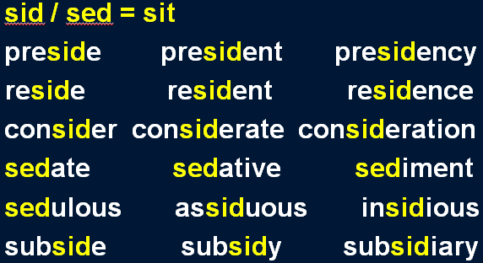

* I wanna hold you till I die, till we both break down and cry. I wanna hold you till the fear in me **subsides**.
* **profound** [prə'faʊnd] adj. 深刻的，深远的，极度的
* a **profound** effect / influence / impact 深远的影响
* a **profound** poem 深奥的诗
* a **profound** question 有深度的问题
* **profound** sadness 深深的悲伤
* **profound** irritation 极度的烦操
* **maximum** ['mæksɪməm] adj. 最大的
* **maximum** amount（修饰不可数） / number（修饰可数）最大量
* **maximum** temperature 最高温度
* **maximum** voltage 最高电压

**【同根词】**

**maximize** vt. 取…最大值；对…极为重视 vi. 尽可能广义地解释；达到最大值

* to **maximize** profits
* to **maximize** windows

**maximization** n. [数] 极大化，最大化

* the **maximization** of profits

**【反义词】**

**minimum** n. 最小值；最低限度；最小化；最小量 adj. 最小的；最低的

* **minimum** wage最低工资

**minimize** vt. 使减到最少；小看，极度轻视 vi. 最小化

* to **minimize** the civilian casualties

**minimization** n. 减到最小限度；估到最低额；轻视

* **mobile** ['məʊbaɪl] ['moʊbl] adj. 可移动的
* **mobile** home
* **mobile** library
* **mobile** phone 手机

**【扩展】**

cell / cellular phone 手机

**【词缀】**（构成形容词和名词）表示“能”，“倾向”，“关系”

host**ile** n. 敌对 adj. 敌对的，敌方的；怀敌意的

doc**ile** adj. 温顺的，驯服的；容易教的

fert**ile** adj. 富饶的，肥沃的；能生育的

frag**ile** adj. 脆的；易碎的

fut**ile** adj. 无用的；无效的；没有出息的；琐细的；不重要的

infant**ile** adj. 婴儿的；幼稚的；初期的

juven**ile** adj. 青少年的；幼稚的

miss**ile** adj. 导弹的；可投掷的；用以发射导弹的

ag**ile** adj. 敏捷的；机敏的；活泼的

rept**ile** adj. 爬虫类的；卑鄙的

* **snore** [snɔ:(r)] v. 打呼噜，打鼾

**【辨析】**表达“气流声音”：

**snore** 打呼噜，打鼾

**sneeze** 打喷嚏

**sniff** 嗅；闻；

**gasp** 喘气

**sigh** v.叹息，叹气

**yawn** n. 哈欠；裂口 ；vt. 张开；打著哈欠说；vi. 打哈欠；裂开

**blow one’s nose** 擤鼻涕

**clear one’s throat** 清嗓子

**break wind** / **fart** 放屁

课文讲解

# （第一段）

# Pollution is the price we pay for an overpopulated, overindustrialized planet.

**语法分析:**

Pollution is the price we pay for an overpopulated, over industrialized planet（定语从句）.

知识点（1）

**写作题材：**“污染”

* **话题：**环境污染正在变得越来越严重
* Environmental pollution is becoming increasingly serious.
* Environmental pollution is a serious problem / issue.
* Environmental pollution is a global problem / issue.
* Environmental pollution is an issue that crosses the national boundaries.
* **话题：** 我们应该关注环境问题
* We should pay attention to the issue of environmental pollution.
* We should show concern for environmental pollution.
* We should attach more importance / significance to the issue of environmental pollution.
* We should make efforts to tackle the problem of environmental pollution.

知识点（2）

**… be the price sb. pay for …** 某个东西是某人为某事付出的代价

* **造句：**沙尘暴 (dust storm) 是我们为过度砍伐 (tree felling) 付出的代价。
* Dust **storms are the price we pay for** excessive tree felling.
* **造句：**这次事故是他为疏忽 (negligence)付出的代价。
* The **accident is the price he pays for** his negligence.

**be a small price to pay for sth.** （Lesson18）对…来说是很小的代价

* **造句**：损失点钱对于提高地位来说算不了什么。
* The loss of money **is a small price to pay for** the rise in status.

**be a high price to pay for sth.** 对…来说是很高的代价

* **造句**：为了成功牺牲健康不值得。
* The sacrifice of health **is a high price to pay for** success.

# When you come to think about it, there are only four ways you can deal with rubbish: dump it, burn it, turn it into something you can use again, attempt to produce less of it.

**语法分析:**

When you come to think about it（时间状语从句）, there are only four ways you can deal with rubbish（定语从句，修饰）: *dump it（做*four ways的*同位语）, burn it（做*four ways的*同位语）, turn it（做*four ways的*同位语） into something you can use again（定语从句，修饰something）, attempt to produce less of it*.

知识点（1）Lesson14、38、42

**come to do** 1.开始做某事；2.逐渐慢慢做某事；3.无意的、意外的、碰巧做某事

* When you **come to think**（开始做某事） about it …
* Future historians will be in a unique position when they **come to record**（开始做某事） the history of our own times.
* He soon made a name for himself and **came to be**（逐渐慢慢的） known to the Italians as Giovanni Acuto.
* A body **came to be**（无意的、意外的、碰巧做某事） found under the bridge.

知识点（2）

**语法**：列举句型

… there are only **four ways** …

**there are ... ways（方式） / kinds（种类） / sorts（种类） / types（种类） / categories（种类） / classes（种类） ...**

* **There are three categories** of accommodation: **economical**, **standard** and **deluxe**.

**【扩展】**

**fall into ... categories** （列举）分成不同种类

* Shakespeare’s plays **fall into three categories**: **tragedies** such as Hamlet, **comedies** such as The Merchant of Venice and **histories** such as Henry Ⅳ.

**be divided into ... classes** （列举）被分成…的类别

* Broadly speaking, human beings may **be divided into** three **classes**: those who are **toiled to death**, those who are **worried to death**, and those who are **bored to death**.

知识点（3）复习

deal with 处理

**【近义词组】**表达**“处理”**：

**dispose of** rubbish / garbage

rubbish / garbage **disposal**

知识点（4）

… turn it into something you can use again…

* **写法替换**
* **recycle it** 回收

# We keep trying all four methods, but sheer volume of rubbish we produce worldwide threatens to overwhelm us.

**语法分析:**

We keep trying all four methods, but（并列） the sheer volume of rubbish we produce worldwide（定语从句） threatens to overwhelm us.

知识点（1）

**sheer** （语气词，强调数量大）

**the sheer volume of sth.** （数量）巨量的、海量的

**the sheer size of sth.** （尺寸）巨量的

* The **sheer size of the** country makes communications difficult.

知识点（2）复习

**threaten to do** 1.（人做主语）威胁做某事；2. （物做主语）有…的威胁

* They **threatened to**（人做主语） kill him if he didn’t obey.
* Mining operations **threaten to** （物做主语）destroy our environment.

**【扩展】**

**promise to do** 1.（人做主语）承诺做某事；2. （物做主语）有…的可能

* He **promised to** （人做主语）call me every week.
* It **promises to**（物做主语） be warm today.

# （第二段）

# Rubbish, however, is only part of the problem of polluting our planet.

知识点（1）Lesson35、41

**语法：**当 **“part of”** 之前没有形容词修饰时，通常不加不定冠词 **“a”**

* Justice is **part of** the complex machinery of the law.
* **Part of** the building was destroyed in the fire.
* Falling over is **part of** learning how to ski.
* This idyllic pastoral scene is only **part of** the picture.
* Memory loss is **a *normal* part** of the aging process.
* … so vast is the number of planets, that intelligent life is bound to be **a *natural* part of** the universe.

# The need to produce ever-increasing quantities of cheap food leads to a different kind of pollution.

**语法分析:**

The need to produce ever-increasing quantities of cheap food (动词不定式做定语) leads to a different kind of pollution.

知识点（1）Lesson38

ever increasing 不断增加

**【近似词组】**表达“不断地”

* … evidence that steadily accumulates
* … the **ever-accumulating** evidence
* the world that **steadily** changes
* the **ever-changing** world
* the knowledge that **steadily** grows
* the **ever-growing** knowledge
* the economy that **steadily** develops
* the **ever-developing** economy
* the market that **steadily** expands
* the **ever-expanding** market
* the reform that **steadily** deepens
* the **ever-deepening** reform
* the resources that **steadily** dwindle
* the **ever-dwindling** resources
* **造句：**满足人们不断增长的物质和文化生活需求的需要
* the need to satisfy people’s **ever-increasing** demands for material and cultural life.

知识点（2）Lesson5、33

leads to 导致；通向

* Hundreds of steps **lead to**（通向） the high wall which surrounds the president's palace.
* This **led to**（导致）yet another angry argument.

# Industriallized farming methods produce cheap meat products: beef, pork and chicken.

知识点（1）

**farming** n.养殖

* pig **farming**
* cattle **farming**
* chicken **farming**
* poultry **farming**
* livestock **farming**

**farm** v.养殖

* **farmed** fish
* **farmed** shrimp

知识点（2）

**写作**：押韵

* **produce** cheap meat **products**
* assist **burglars** to **burgle**
* **live** a ... **life**
* **sing** a **song**
* **breathe** one’s last **breath**
* **die** a glorious **death**

知识点（2）

**chicken** 1.小鸡（可数）；2.鸡肉（不可数）

* eat chicken

**lamb** 1.羊羔（可数）；2.羔羊肉（不可数）

**turkey** 1.火鸡（可数）；2. 火鸡肉（不可数）

**duck** 1.鸭子（可数）；2. 鸭子肉（不可数）

**lobster** 1.龙虾（可数）；2. 龙虾肉（不可数）

...

# The use of pesticides and fertilizers produces cheap grain and vegetables.

# The price we pay for cheap food may be already too high: Mad Cow Disease (BSE) in cattle, salmonella in chicken and eggs, and listeria in dairy products.

**语法分析:**

The price we pay for cheap food（定语从句） may be already too high: *Mad Cow Disease (BSE) in cattle（做*The price的*同位语）, salmonella in chicken and eggs（做*The price的*同位语）, and wisteria in dairy products（做*The price的*同位语）*.

知识点（1）

**… be the price sb. pay for …** 某个东西是某人为某事付出的代价

**the price sb. pay for ...**

* Pollution is **the price we pay for** an overpopulated, over-industrialized planet.

**【扩展】**表达“代价”相关：

* The precious information came **at a price**（付出代价）.
* The precious information came **at a heavy price**（付出沉重的代价）..
* She is determined to have a child **at any price**（不惜一切代价）..

**at the expense of ...** 以损害…为代价

* Military strength is often achieved **at the expense of** a country’s economic health.
* The Roosevelt Administration believed that rebuilding the nation’s soil was in the national interest and was not simply a plan to help farmers **at the expense of** other citizens.

知识点（2）

**【总结】【复习】**本身是复数的名词：

**cattle**

**people**

**police**

知识点（3）

**【辨析】**

**dairy** 奶制品

* dairy products
* dairy cattle

**diary** 日记

* keep a diary

【扩展】字母改变顺序的单词：

**angle** / **angel**

**altitude** / **latitude**

**aboard** / **abroad**

知识点（4）【课文仿写】

* 造句：我们为人口过多付出的代价可能已经太高了：失业现象，各种各样的污染，以及越来越多的 (ever-increasing) 犯罪。
* The price we pay for overpopulation may be already too high: unemployment, pollution of all kinds, and the ever-increasing crime.

# And if you think you'll abandon meat and become a vegetarian, you have the choice of very expensive organically-grown vegetables or a steady diet of pesticides every time you think you're eating fresh salads and vegetables, or just having an innocent glass of water!

**语法分析:**

And（连接上一句话，表相关） if（条件状语从句） you think you'll abandon meat **and** become a vegetarian（宾语从句）, you have the **choice of very expensive organically-grown vegetables or a steady diet of pesticides**（固定搭配**choice of … or…**） **every time** *you think you're eating fresh salads and vegetables, or just having an innocent glass of water（宾语从句）*!（**every time… 时间状语**）

知识点（1）

**have the choice of A or B** 在A和B之间选一个

知识点（2）

**organically-grown** 有机栽培的

* **organically-grown** vegetables
* **organically-grown** produce

**【扩展】**

**environment-friendly** 环保的

* **environment-friendly** products

知识点（3）

**steady** adj.稳定的，持续的

* a **steady** job / income
* a **steady** relationship
* a **steady** boyfriend / girlfriend
* a **steady** decline / increase

知识点（4）

**every time (when) ...** （every time可以看作连词，也可以看作名词time做状语加when引导的定语从句）**每当**

= **whenever** ...

= **no matter when ...**

知识点（5）

**innocent** adj. harmless, innocuous 无害的、无毒的

知识点（6）【课文仿写】

* **造句:** 如果你想放弃开车, 那么你可以两者选一: 或者是慢得出奇 (extraordinarily slow) 的公共汽车,或者是过分拥挤 (over-crowded) 的地铁。
* If you think you’ll abandon the car, you have the choice of the extraordinarily slow buses or the over-crowded subway.

# （第三段）

# However, there is an even more insidious kind of pollution that particularly affects urban area and invades our daily lives, and that is noise.

**语法分析:**

*However（插入语）*, there is an even more insidious kind of pollution that particularly affects urban areas and invades our daily lives（宾语从句）, and that is noise.

知识点（1）【课文仿写】

* **造句**: 有一种更为隐蔽有害的侵略, 它尤其影响人们的思维模式 (mode of thought) 并侵犯当地的传统, 那就是文化侵略。
* There is an even more insidious kind of aggression that particularly affects people’s mode of thought and invades local tradition, and that is cultural aggression.

# Burglar alarms going off at any time of the day or night serve only to annoy passers-by and actually assist burglars to burgle.

**语法分析:**

Burglar alarms going off at any time of the day or night（非谓语动词做后置定语,修饰alarms） serve only to annoy passers-by and actually assist burglars to burgle.

知识点（1）

**go off** 发出巨大的声音

* The alarm clock **went off.**
* The gun **went off** accidentally.
* The bomb **went off** at midnight.

**【总结】【复习】**声音动词

**ring** 门铃、电话响

* The phone / doorbell **rang**.

**strike** 当当当的响

* The clock was **striking** the hours.
* The clock began to **strike** twelve.

**blare** 车喇叭声音

**roar** / **thunder** 呼啸的声音

* The silence was suddenly broken when a large car, with its headlights on and its horn **blaring**, **roared** down the arcade.

**whine** 机器轰鸣声

知识点（2）Lesson25

**serve to do** 发挥某个作用

* His death **serves to** remindus how dangerous using drugs can be.

**serve as ...** 某个东西发挥某个作用

* She **serves as** an impressive reminder of the great ships of the past.

# Car alarms constantly scream at us in the street and are a source of profound irritation.

知识点（1）Lesson15

a source of 来源

* ..., but uncles and aunts are always **a source of** extra income.

# A recent survey of the effects of noise revealed (surprisingly? ) that dogs barking incessantly in the night rated the highest form of noise pollution on a scale ranging from 1 to 7.

**语法分析:**

A recent survey of the effects of noise（后置定语） revealed (surprisingly? （插入语）) **that** dogs barking incessantly in the night（后置定语） rated the highest form of noise pollution ***on a scale（状语）*** *ranging from one to seven（后置定语）*. （**that**… 宾语从句）

知识点（1）

**survey** / **poll** / **opinion poll** 民意测验

**【扩展】**

**census** （官方的）统计；人口普查；人口调查

* the Fifth National **Census**

**investigation** （正式的）调查，侦查

* the **investigation** of the case / market ...

知识点（2）

**rate** v.评定…

* The essay **rates** a low grade.

知识点（3）

**on a scale** 在这样一个级别里面 （**书上翻译有误**）

* The earthquake measured 8.0 **on the** Richter **scale**.
* The students **rate** the teachers **on a scale** of 1 to 5.

知识点（4）

**range from A to B** 在A到B的范围内

= **range between A and B**

* The team contained ten players whose ages **ranged from 10 to 16** / **ranged between 10 and 16**.

# The survey revealed a large number of sources of noise that we really dislike.

# Lawn mowers whining on a summer's day, late-night parties in apartment blocks, noisy neighbours, vehicles of all kinds, especially large container trucks thundering through quiet villages, planes and helicopters flying overhead, large radios carried round in public places and played at maximum volume.

**语法分析:**

（整句话都是名词短语，作为前一句noise的同位语，前面用逗号比较合适）

Lawn mowers whining on a summer's day（后置定语）, late-night parties in apartment blocks（后置定语）, noisy neighbors, vehicles of all kinds, especially large container trucks thundering through quiet villages（后置定语）, planes and helicopters flying overhead（后置定语）, large radios carried round in public places（后置定语） and played at maximum volume（后置定语）.

知识点（1）

**apartment block** 公寓大楼

**office block** 办公大楼

# New technology has also made its own contribution to noise.

# A lot of people object to mobile phones, especially when they are used in public places like restaurant or on public transport.

知识点（1）

**object to + n.** 反对某事

= **oppose + n.**

**【扩展】**

**protest (against) + n.** 示威、抗议

**boycott + n.** 抵制某事

**【扩展】【反义】**

**support / back + n.** 支持某事

**be behind + n.** 支持某人某事

**stand by + n.**  支持某人某事

**advocate / endorse + n.** 公开支持、公开鼓吹

知识点（2）

**public transport** 公共交通工具

= **public transportation**

= buses, trains etc.

# Loud conversations on mobile phones invade our thoughts or interrupt the pleasure of meeting friends for a quiet chat.

知识点（1）

**on** mobile phones **on** 使用

* She is on the phone / computer.
* She is playing a piece of music **on** the piano.

知识点（2）

**mobile phone** 手机

= **cell / cellular phone**

# The noise pollution survey revealed a rather surprising and possibly amusing old-fashioned source of noise.

# It turned out to be snoring!

# Men were found to be the worst offenders.

# It was revealed that 20% of men in their mid-thirties snore.

知识点（1）

**mid-thirties** 三十岁中期

**early thirties** 三十岁早期

**late thirties** 三十岁晚期

# This figure rises to a staggering 60% of men in their 60s.

知识点（1）Lesson8

**rise / increase / jump / soar / rocket / spiral to...** 上升到

**fall / drop / plunge / dive / plummet to ...** 下降到

# Against these figures, it was found that only 5% of women snore regularly, while the rest are constantly woken or kept awake by their trumpeting partners.

知识点（1）

**against** … 与…相比

= **compared to / with ...**

= **in / by comparison to / with ...**

= **in / by contrast to / with ...**

**A as against B is as C against D** A和B相比就如同C和D相比一样

* The military power of the US, **as against** that **of** DPRK, **is as** the strength of an
* elephant **against** that of a mouse.

# Whatever the source of noise, one thing is certain: silence, it seems, has become a golden memory.

知识点（1）

**语法：**whatever 引导让步状语从句时，常省略 be 动词。

* Whatever the source of noise **(is)**, one thing is certain : ......
* After all, whatever her faults **(are)**, she is your mother.
* The country is always beautiful whatever the season **(is)**.

知识点（2）Lesson9

**a golden** memory 金子般的回忆

**a golden** opportunity 金子般的机会